MOD_LPC Schema - Current State Analysis

Section 1: Schema at a Glance

1.1 Database & Schema Identification
- Schema Name: MOD_LPC
- Database: MOD_PROD

1.2 Total Schema Size
- Total Storage (TB) : 34.5 TB
- Total Storage Segments : 2,201- Include everything
- Storage Cost (Capital) : ~$70.6 Million at $2,000/TB

1.3 Total Object Inventory

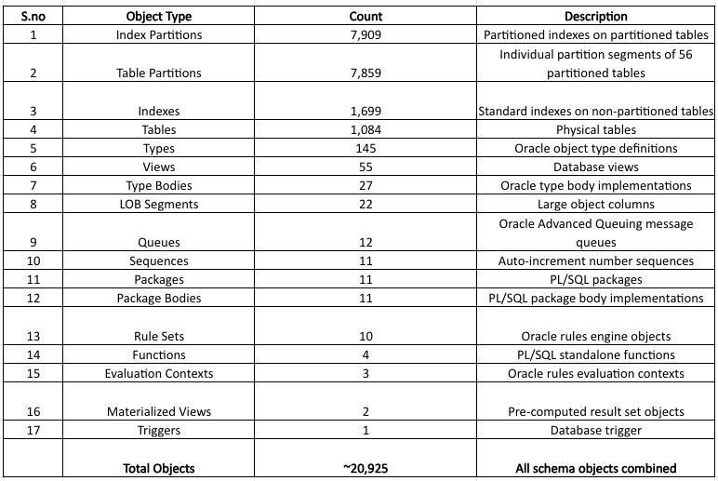
The schema contains 7,859 partitions and 1699 indexes, Oracle backup process each segment independently, That is why backup takes 7 days.

1.4 Table Structure — Partitioned vs Non-Partitioned

Non-Partitioned Tables : 1,028
Partitoned Tables : 56
Total : 1,084

Details of Partitioned Tables
Partitioned Tables : 56
Total Partition Segments Generated: 7,859
Largest Partitioned Table : MKTPLANPNODE- 2,453 partitions
Second Largest Partition: MKTPLANPNODECONSTRAINT_D - 1,580 partitions

1.5 LOB Column Inventory
LOB (Large Object) columns store unstructured data as XML documents, binary files.
The schema contains 22 LOB column definitions across 9 tables.
All 22 LOB column segments are currently consuming zero storage. The columns exist as schema definitions but contain no data.

Section 2: Table Analysis & Classification

2.1 Total Table Count
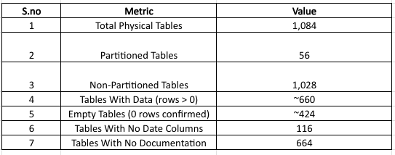

2.2 Classification of Tables
naming conventions were analyzed across the full table list to identify consistent patterns.
1. Prefix Analysis: Every distinct table name prefix is taken to identify groups
2. Suffix Analysis: Every distinct table name suffix is taken to identify groups
No single standardized naming convention exists across the schema. Multiple teams over multiple years created tables with inconsistent naming. This made classification of groups incomplete —
A manual review pass was required to catch non-standard backup table names like BKP_MKTREASON_OCT232025, MKTPLANPNODE_TEMP_4AUG2025, and date-stamped names like MKTCASE_05042020.

2.3 The 34 Functional Groups
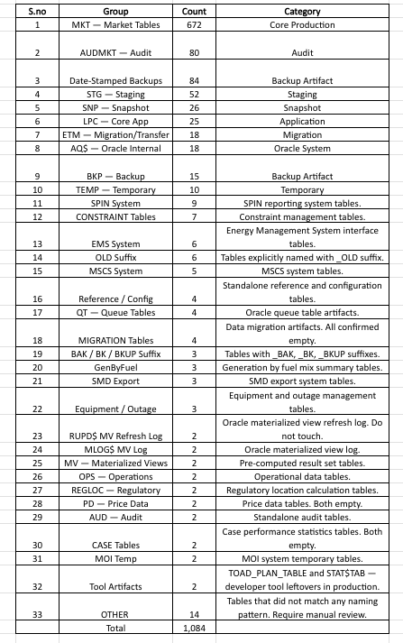

2.4 Naming Convention Patterns Identified
During classification, the following naming patterns were identified.
Prefix Patterns
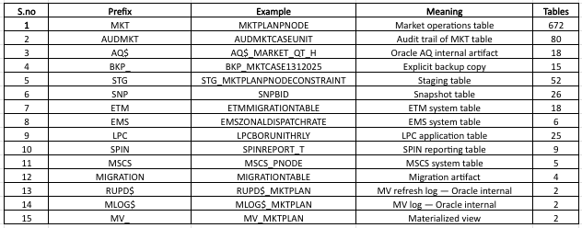

Suffix Patterns Inside MKT Tables
This is particularly important. Within the 672 MKT tables, multiple suffix patterns exist that indicate copies of base tables:
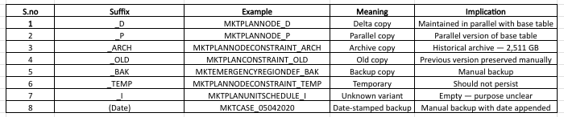
The presence of _D, _P, _ARCH, _OLD, _BAK and date-stamped variants within MKT tables indicates a pattern of manual table copying that accumulated over years without a consistent naming standard or cleanup process. These variants account for a significant portion of storage within the MKT group.

Non-Standard Backup Names — The Problem
At least 10 different naming conventions were used to create backup copies across the schema. This is why automated detection caught only 84 date-stamped tables through regex — a manual review pass was necessary to identify the full population of backup artifacts.
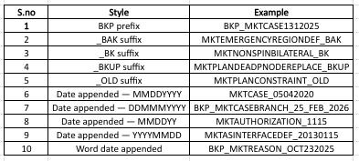
2.5 Empty vs Populated Tables
Table with data-(Num_rows>0) : 660
Empty tables- (Num_rows<0) : 424
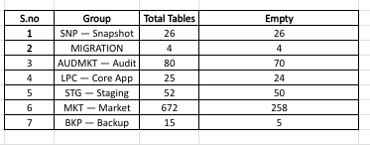
Finding 1 — SNP and MIGRATION groups are 100% empty. All 26 snapshot tables and all 4 migration tables have zero rows. These groups appear to be created that was set up but never populated, or was populated, used and then cleared. Either way they represent 30 tables with no current data value.
Finding 2 — 258 MKT tables are empty. Even within the core production group tables are empty. This means 258 of the 672 MKT tables exist in the schema as definitions — with indexes, constraints and backup overhead — but store no data.
Finding 3 — 70 of 80 AUDMKT audit tables are empty. The audit framework was built for 80 tables but only 10 are receiving audit records. The remaining 70 audit tables are defined but hold no audit trail.

2.6 Tables With No Date Columns — 116 Tables
During the data age analysis phase, every table was checked for the presence of CREATEDDATE or MODIFIEDDATE columns.
This check revealed that 116 tables have no date or timestamp columns at all.
Tables WITH date columns: 968
Tables WITHOUT any date columns: 116
Some tables have different names
CREATIONTIME, HISTCREATEDDATE,HISTMODIFIEDDATE, BATCHCREATEDDATE, BATCHMODIFIEDDATE, LASTUPDATE, CREATEDDATE, MODIFIEDDATE

Which groups have no date columns:
AQ$ Oracle Internal, SNP Snapshot, MIGRATION, LPC internal,STG farm tables. Oracle system
For that we used the below for the age analysis.
DBA_TABLES.LAST_ANALYZED — when Oracle last gathered statistics
DBA_TAB_MODIFICATIONS.TIMESTAMP — when DML was last tracked.

Section 3: Storage Distribution

3.1 Storage by Group
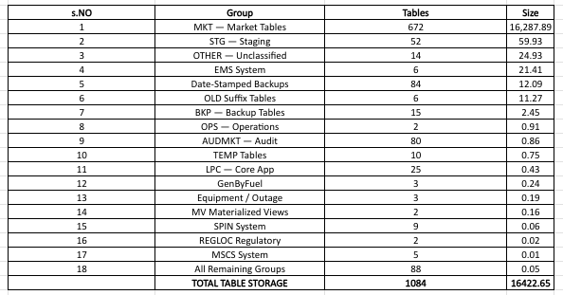
3.2 Top 10 vs Bottom 10 storage
Top-10 distribution according to the storage
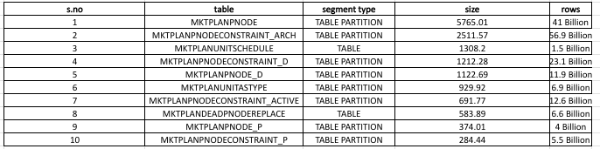
Bottom-10 distribution according to the storage
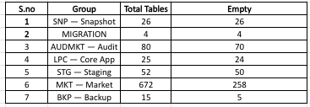

Section 4: Usage & Activity Metrics
Two views are used for the determination of table usage.
DBA_TAB_MODIFICATIONS - Tracks INSERT, UPDATE, DELETE counts and timestamp since last stats gathe
DBA_TABLES.LAST_ANALYZED - When Oracle last gathered statistics on the table
ACTIVEDML : detected within last 6 months
RECENTDML : detected 6–12 months ago
AGING : Last DML 1–5 years ago
STALE : Last activity 2016–5 years ago
PRE-2016 : Last activity before January 2016

4.1 Activity by group
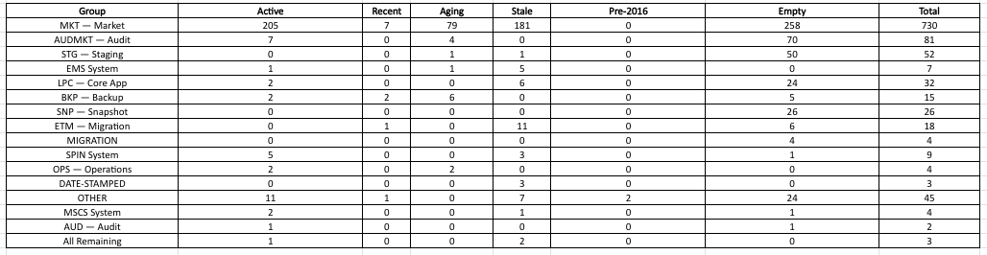
4.2 Top and Bottom usage metrics

Top 10 — High Activity
These are the tables receiving the highest volume of data changes in the schema right now.
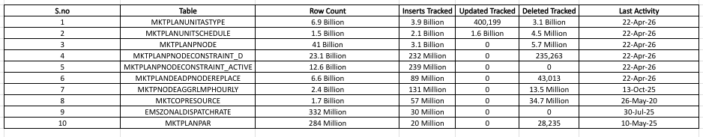

Bottom 10 — Lowest Activity (With Data, Not Empty)
These are the 10 tables that have rows but show the least write activity — either zero DML tracked or last activity the furthest in the past.
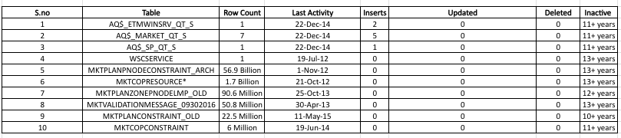
4.3 Tables Confirmed Dead — Entire Groups With Zero Activity
SNP-Snapshot : 26 tables - 0 rows - Last Activity is on 27 Jan 2017
Migration : 4 tables - 0 rows - Last Activity is on 27 Jan 2017
Both groups share the exact same last analyzed date — 27-JAN-2017.
4.4 Most critical examples — large active tables with stale statistics:
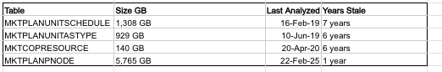
Findings:
A large number of tables across multiple groups share the same 27-JAN-2017 last analyzed date:
SNP — All 26 tables
MIGRATION: All 4 tables
STG — Staging: 48 of 52 tables
LPC — Core App: 22 of 32 tables
ETM — Migration: 11 of 18 tables
MKT — Market (stale subset): ~150 tables
AQS — Oracle Internal: Multiple tables
The August–September 2021 Pattern — The _P Tables
All _P (Parallel copy) tables largely stopped receiving writes around Aug–Sep 2021, with many showing last activity on 02-SEP-2021.
Tables with last activity on 02-SEP-2021 (inactive since then):
MKTPLANNODE_P (374.01 GB)
MKTPLANNODECONSTRAINT_P (284.44 GB)
MKTPLANDISPATCH_P (0.42 GB)
MKTPLANPRD_P (1.33 GB)
Tables with later but still outdated activity (2022):
MKTPLANLRASTYPE_P → 04-OCT-2022
MKTPLANLRSERVICE_P → 23-SEP-2022
MKTPLANLOCALEPRODUCT_P → 22-SEP-2022
Tables still active (2025 activity):
MKTPLANLOCALE_P → 22-JUL-2025 (still active)
MKTPLANUNITASTYPE_P → 22-NOV-2025 (still active)
MKTPLANUNITSCHEDULE_P → 25-OCT-2025 (still active)

Section 5: Content & Metadata Analysis
5.1 Capturing comments- Initial analysis for the description of tables
Three Oracle system views were used to build the metadata picture:
DBA_TAB_COMMENTS : Free-text description of each table's purpose — added by developers at creation time
DBA_TAB_COLUMNS: Every column in every table — name, data type, position, nullable
DBA_COL_COMMENTS: Free-text description of individual columns — added by developers
Table with comments - 420
Table without comments - 664
5.2 Top 10 widest columns by column count
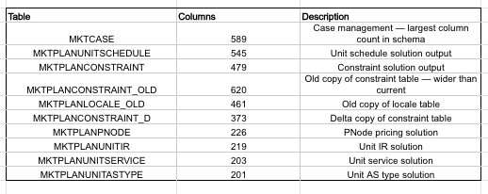
Finding:
The analysis shows that MKTPLANCONSTRAINT_OLD contains 620 columns, while the current MKTPLANCONSTRAINT table has only 479 columns, indicating that the old copy was taken when the schema was wider and before columns were later removed as part of schema. MKTCASE stands out with 589 columns, making it the widest table in the schema; such a high column count reflects continuous accumulation of requirements over time and makes the table harder to maintain, query, and index efficiently.
5.3 Table Definitions — Extracted from comments
- MKTPLANPNODE
"This entity is used to hold the case solution PNODE price calculations."
Columns: 226
Size: 5,765 GB
Rows: 41 Billion
- MKTCASE
"This entity is used to describe a Multi-Settlement Market study case. A case is used by a single user to study the day ahead market or supplementary commitment based on a set of configuration. The per case configuration attributes are stored in this entity while a finer grain per hour configuration is stored in MktCaseControl."
Columns: 589
Size: 0.89 GB
Rows: 3.3 Million
- MKTPNODEPNODEHOURLY
"This table holds hourly factor data for pnode and its aggregate. This table is partitioned by day on MKTHOUR. Partitions are maintained by PJM."
Columns: 125
Size: 123 GB
Rows: 858 Million
- EMSZONALDISPATCHRATE
"This entity contains the EMS zonal electronic rates used to dispatch units within the PJM control area. The information comes from Drate.txt file Start Rate Data — End Rate Data section."
Columns: 88
Size: 21.4 GB
Rows: 332 Million
- MKTPLANPNODECONSTRAINT_ARCH
"This record contains the congestion component of each Pnode to binding constraint. This table is only written out by DSPD in LPC mode."
Columns: 266
Size: 2,511 GB
- MKTDALOCALESUBZONEACTIVE (deprecated example)
"This table was created during Reserve Price Formation but later deprecated with CM-6738."
Columns: 7
Size: 0 GB
Rows: 0

Section 6: Data Age & Archival Analysis
How much data exists in MOD_LPC that is older than January 2016 and has not been modified in the last 10 years?
Used CREATEDDATE and MODIFIEDDATE columns.
6.1 The following tables were identified as likely pre-2016 candidates based on metadata signals and were directly queried.
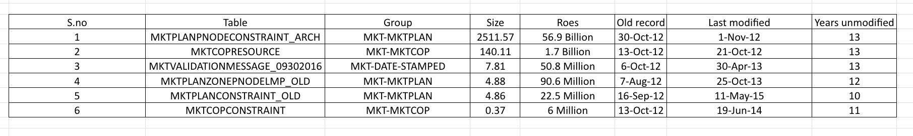
Findings:
- Total GB: 2,669.60 GB
- Total Rows: ~58.8 Billion
- Number of tables: 6 tables
- Largest contributor: MKTPLANPNODECONSTRAINT_ARCH (2,511.57 GB — 94.1% of the total)
- Oldest data found: 07-AUG-2012
- Estimated annual storage cost: ~$5,200 at $2,000/TB
All 6 tables belong to the MKT group.

Executive Summary

Section 1 — Schema at a Glance
- Schema: MOD_LPC — Database: MOD_PROD
- Total size: 35,328 GB (34.5 TB) — 18% larger than prior 30TB estimate
- Total segments: 2,201 — includes everything (tables, indexes, partitions)
- Annual storage cost: ~$70,600 at $2,000/TB
- Total objects: ~20,925 across 17 types
- Largest object types: Index Partitions (7,909), Table Partitions (7,859), Indexes (1,699), Tables (1,084)
- Partitioned tables: 56 — generating 7,859 partition segments
- Non-partitioned tables: 1,028
- Largest partitioned table: MKTPLANPNODE — 2,453 partitions
- Backup takes 7 days because: 7,859 partitions + 1,699 indexes = 9,558 segments processed individually
- LOB columns: 22 across 9 tables — all consuming 0 GB
Section 2 — What Tables Exist
- Total tables: 1,084
- Tables with data: ~660
- Empty tables: ~424 (43%)
- Tables with no date columns: 116 — cannot be age-assessed
- Tables with no documentation: 664 (61%)
- Classification approach: prefix analysis + suffix analysis + manual review
- 34 functional groups identified — MKT (672) is the largest
- 10 different backup naming conventions — BKP_ prefix, _BAK, _BK, _BKUP, _OLD, and 5 date formats
- SNP (26 tables) and MIGRATION (4 tables) — 100% empty, confirmed dead groups
- 258 MKT tables are empty — exist as definitions only, no data
- 70 of 80 AUDMKT audit tables are empty — audit framework built but not activated

Section 3 — Where the Storage Is
- MKT group: 16,287 GB — 46% of entire schema
- Total table storage: 16,422 GB
- Remaining ~18,900 GB is index segments
- 96% of table storage sits in just 56 partitioned tables
- Top 10 tables = 41.8% of entire schema
- MKTPLANPNODE family (7 tables) = 11,961 GB = 33.9% of schema
- Single largest table: MKTPLANPNODE — 5,765 GB, 41 billion rows
- Second largest: MKTPLANPNODECONSTRAINT_ARCH — 2,511 GB, 56.9 billion rows
- Bottom 10 smallest populated tables — all 0.0001 GB — singleton reference tables (1–3 rows each)
- Size range across schema: 57 million to 1 ratio — largest to smallest populated table
Section 4 — Usage of Tables
How usage was measured:
- DBA_TAB_MODIFICATIONS — tracks INSERT, UPDATE, DELETE and timestamp
- DBA_TABLES.LAST_ANALYZED — fallback when DML data is missing
- Combined using NVL logic — DML timestamp first, last analyzed as fallback

%ACTIVE — within 6 months241 22%
RECENT — 6 to 12 months 11 1%
AGING — 1 to 5 years 91 8%
STALE — 2016 to 5 years219 20%
EMPTY — zero rows 464 43%

Section 6 — Pre-2016 Data Age Analysis
Methodology — Three steps:
- MIN(CREATEDDATE) < 01-JAN-2016 → data predates 2016
- MAX(MODIFIEDDATE) < 01-JAN-2016 → not modified in 10 years
- Collect size — both steps must pass
- All _DEF tables excluded per manager's instruction
- Direct queries run on 5–10 million row samples using ROWNUM
- Metadata alone was not sufficient — Oracle re-analyzes stats even on frozen tables
MKTPLANPNODECONSTRAINT_ARCH = 94.1% of the entire pre-2016 total
- All 6 belong to MKT group
- Oldest data: 07-AUG-2012


